**Interquartile Range**

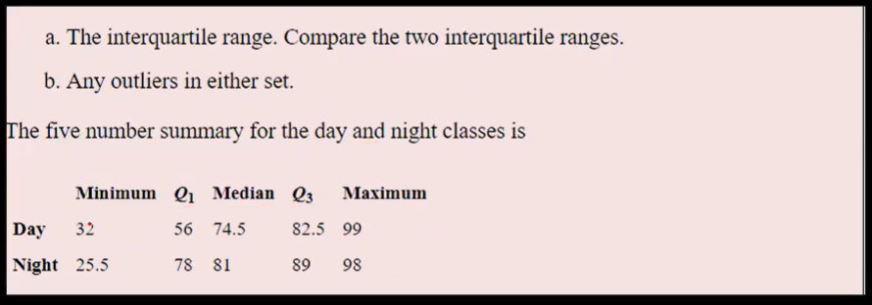

**Day**

Q1 = 56

Q3 = 82.5

IQR = Q3-Q1 = 82.5-56 =26.5

Less Outlier = Q1 – 1.5*IQR = 56-1.5*26.5=56-39.75=16.25

Greater Outlier = Q3 +1.5*IQR = 82.5+1.5*26.5=82.5+39.75= 122.25

Lesser Outlier is there in Day.

Here Min value is 32, in lesser outlier the value be 16.25, i.e. less than min value so lesser outlier is present.

The Greater outlier satisfies the condition the max value is not greater than greater outlier.

**Night**

Q1 = 78

Q2 = 89

IQR = Q3-Q1 = 89-78 =11

Less Outlier = Q1 – 1.5*IQR = 78-1.5*11 =78-16.5= 61.5

Greater Outlier = Q3 +1.5*IQR = 89+1.5*11=89+16.5= 105.5

Here in Night min value is 25.5, less outlier be 61.5, condition is, the value should not be less than 25.5 while comparing less outlier.

In Max value is 98, greater outliers be 105.5, condition is, the value should not be greater than the greater outlier value (i.e.) 105.5.

Here Both in Range so no outliers.